MECH 303

Machine Design

Project 1: Characterization of the Stress Concentration Curves for Plate with Central Hole

Hakancan Öztürk

24 November 2022

**Objective**: Our aim in this project is to derive a stress concentration curve for a flat plate with a central hole. The curve fitting is performed with respect to the diameter to side length ratio to construct a relationship with the stress concentration. The stress concentration is the ratio between the maximum stress which occurs on the loaded specimen and the nominal stress along the sample. When this relationship is generalized, it helps the engineers find the maximum stress magnitude just by the geometry and the axial loading without any need to perform experiments or FEM analyses. The investigated geometry can be found in Figure 1.

**Methodology:** The characterization is done by fitting a curve on a dataset containing different diameter to side length ratio geometries with the same axial loading, material properties, and boundary conditions. The data were generated by using the ANSYS 2021, Static Structural toolbox via preforming FEM analyses. Some of the main steps were as follows; defining the material properties, creating the geometry, parametrizing the hole diameter, adjusting the meshing size and convergence, applying the no-displacement condition and the force on the proper faces of the geometry, solving for the von-Misses stresses, and finally evaluating the maximum equivalent stress for different diameter geometries via the parametrization tool of ANSYS. The corresponding data was processed on MATLAB 2022b, fittings were done via the Curve Fitting Toolbox, and the plotting were again performed on MATLAB.

**ANSYS Setup:** The first step is to determine which physics that we must use to perform a successful analysis to best analyze the given geometry under the provided constraints. The study involves a static solid geometry under static loading therefore we chose Static Structural as the intended study. After selecting the Static Structural, ANSYS creates an environment which encompass the sections: Engineering Data, Geometry, Model, Setup, Solution, and Results as can be seen in Figure 1.

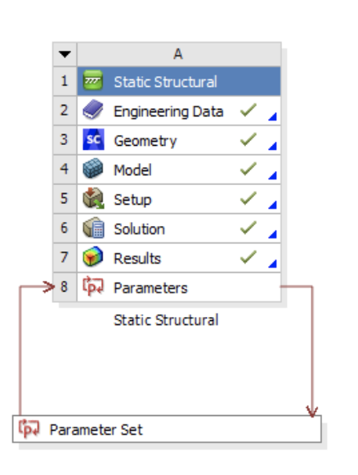

Figure 1. The Static Structural toolbox including the sections, Engineering Data, Geometry, Model, Setup, Solution, Results, and Parameters tab

The second step is to introduce the material that we would like to use and to do this we created a new material under the Engineering Data section and defined some of its physical properties as follows; Young’s Modulus(E)= 210 GPa, density(ρ)= 2100 kg/m3, Poisson’s ratio(γ)= 0.33. The material tab can be seen in Figure 2.

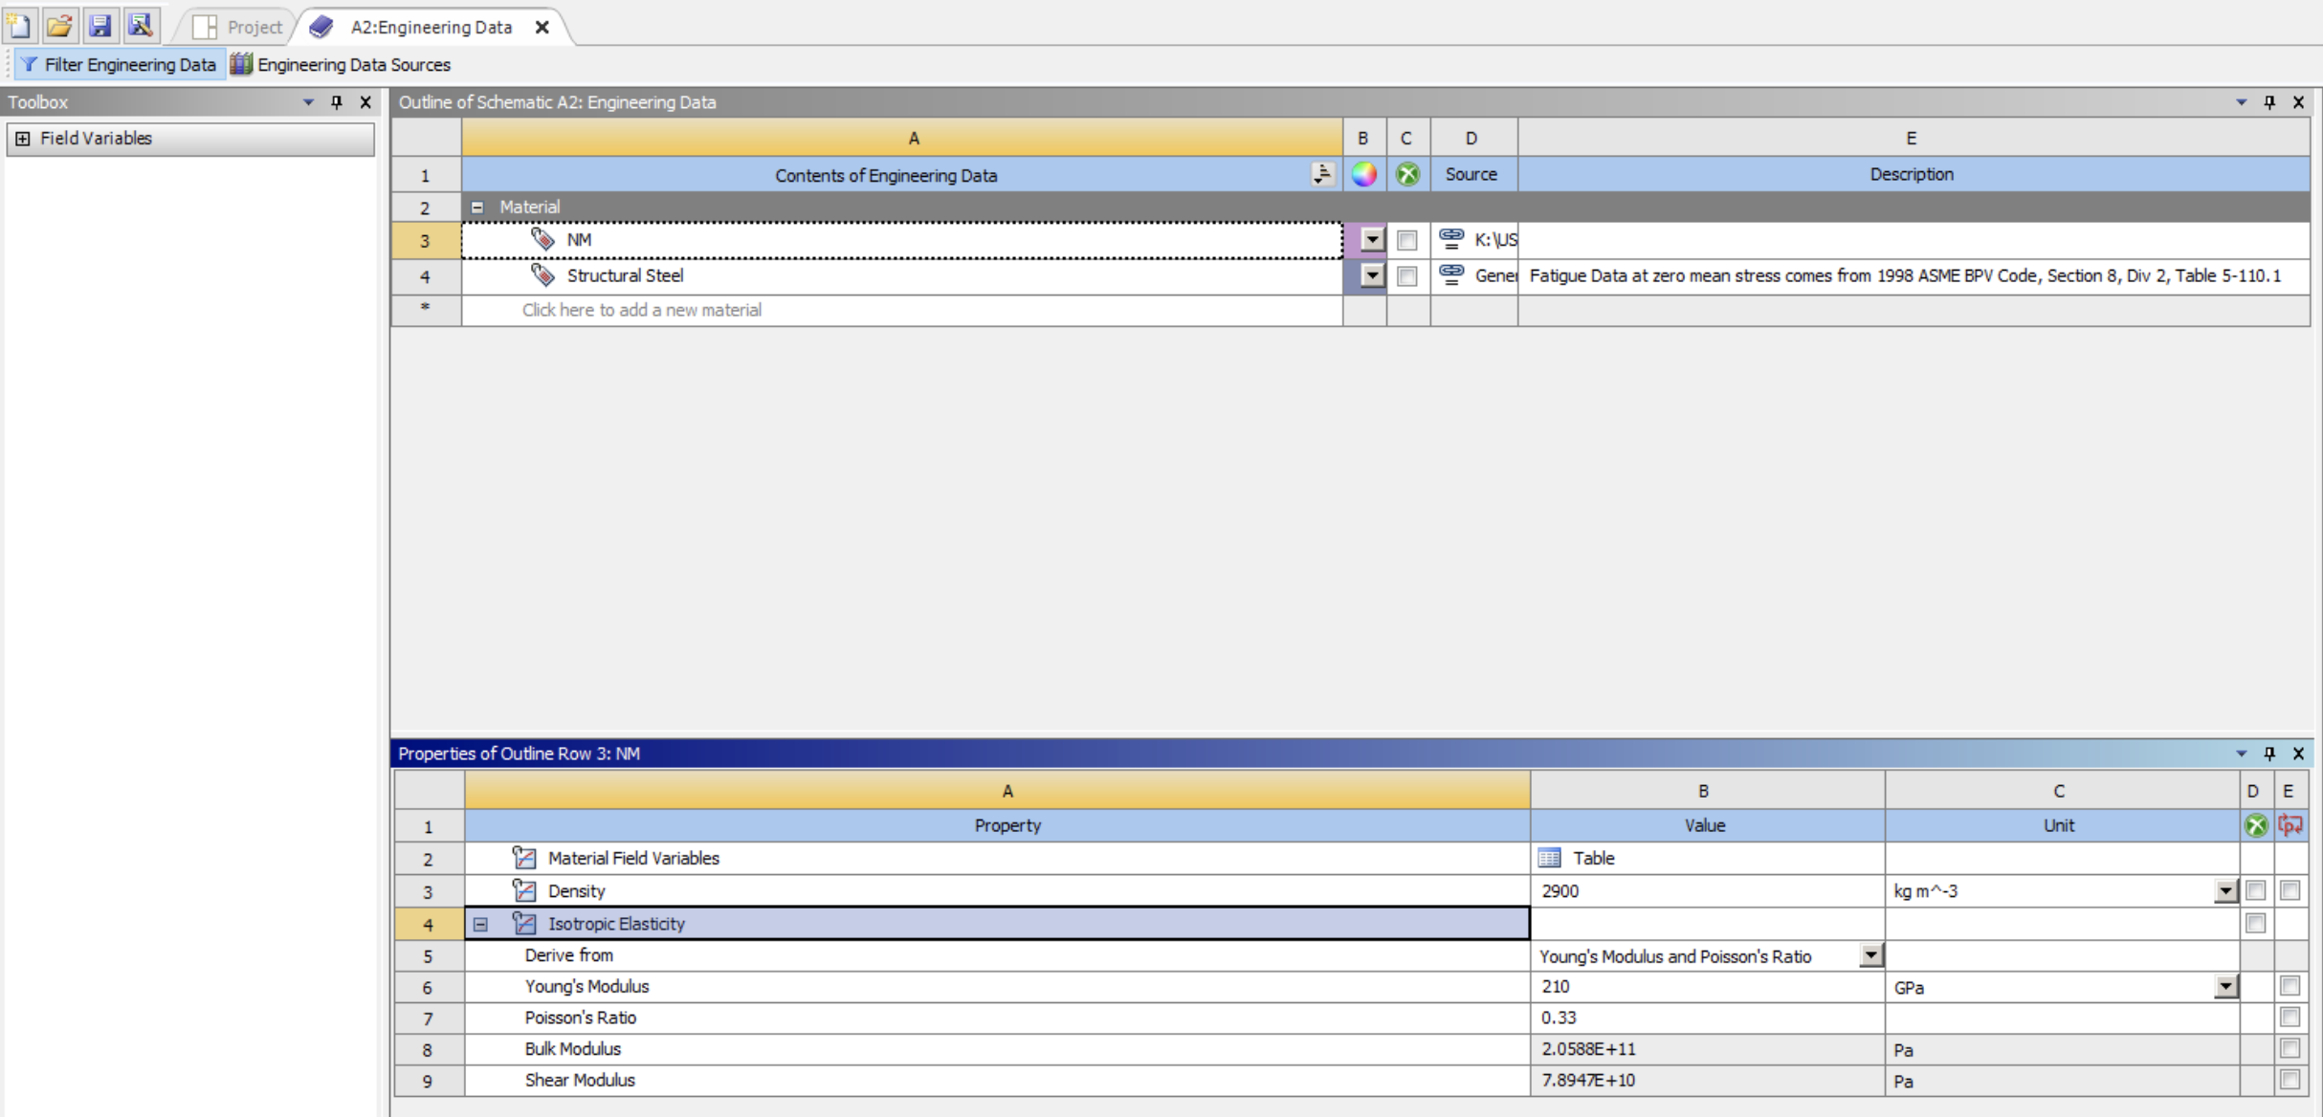

Figure 2. The prescribed materials physical properties including the Young’s Modulus, density, and the Poisson’s ratio

The third step is to create the geometry and parametrize the hole diameter. The geometry was fairly simple to create, it was basically a rectangle sketch with a circle on the middle. The rectangle was 120mm by 40 mm and the initial hole diameter was not critical as long as it was smaller than 24mm so that d/b < 0.6. The sketch was extruded 5mm and the cylindrical part of the geometry was removed so that it acts as a hole. And finally, the hole diameter was parametrized. One of the generic 3D model of the geometry can be seen in Figure 3.

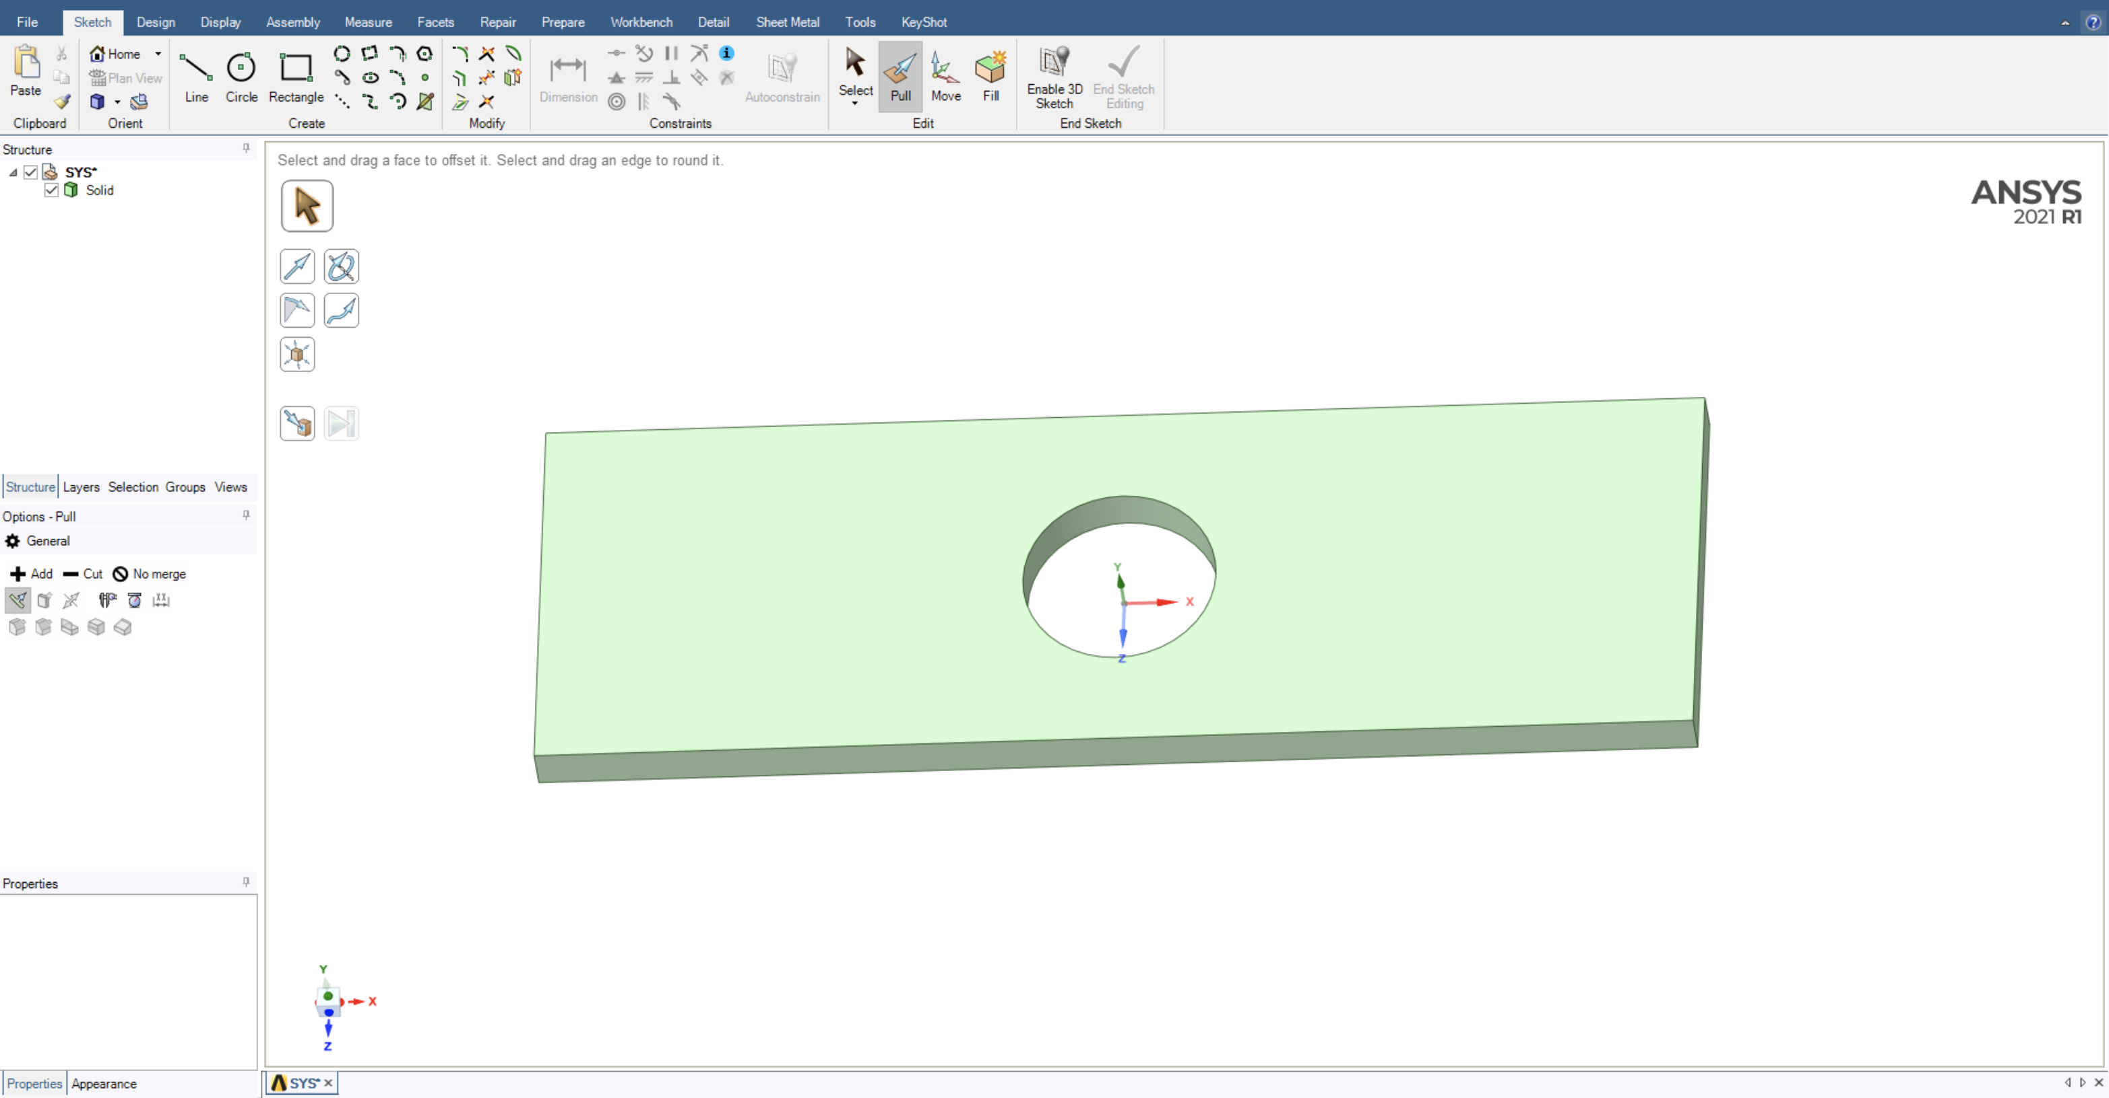

Figure 3. The 3d model of the prescribed geometry at d/b= 0.5.

The fourth step was to introduce the boundary conditions, initial conditions, meshing, and solution. In the setup section, the created geometry was assigned the material that we introduced in the Engineering Data section. The force acting on the plate was introduced with concentrated force on the right face of the plate with magnitude of 2000N in the x-direction. The boundary conditions can be assigned in two different ways, the first way is to set a fixed support on the left side of the plate and the second way is to set three displacement supports where for three different faces of the plate where the normal directions are set to have 0 displacements. The former is an easier way but the latter is more accurate in terms of uniaxial tensile test study. The mesh was refined by setting the body mesh sizing to 1mm and the edge sizing to 0.1mm. The mesh was later tuned further in according with the stress concentrations. One of the meshed geometries can be seen in Figure 5.

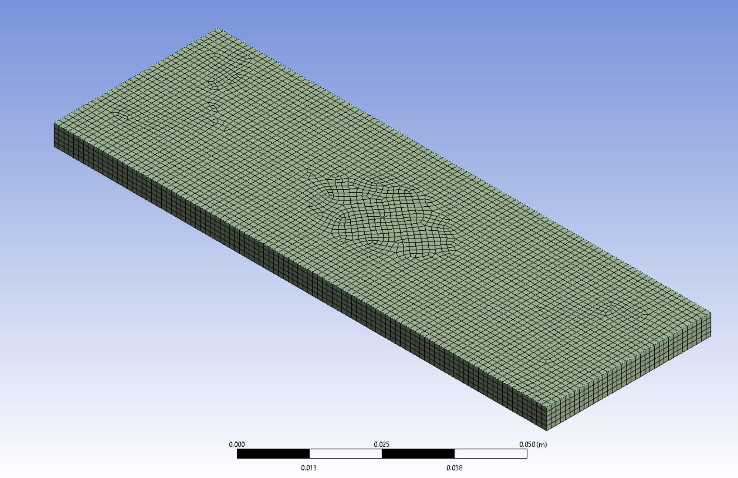

Figure 4. The meshed geometry of d/b= 0.1 and body mesh size= 1mm.

The fifth step was to solve the study and parametrize the intended solution value. The solution was done on the von-Misses stresses by adding it on the solution tab and solving the model for the initial geometry. After the solution stress distribution can be achieved with contour plot and the numerical results appear on the left. The maximum, average, and minimum stress values are tabulated and can each be selected as an output parameter. In our study the maximum stress was intended so we selected the Maximum von-Misses Stress as the output parameter. The sample contour plot of the equivalent stress can be found in Figure 5.

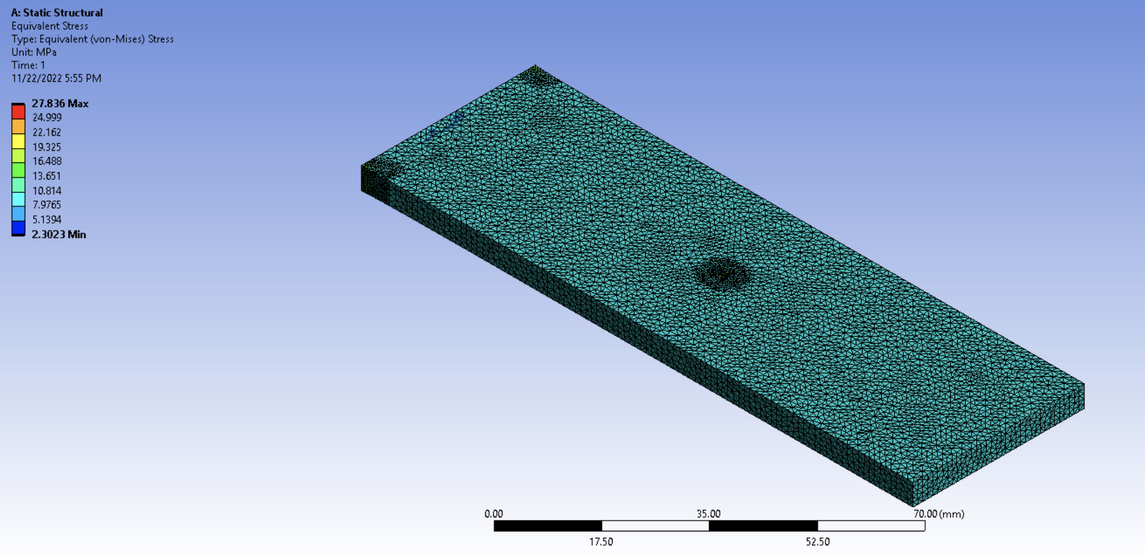

Figure 5. The equivalent stress contour plot

The final step is to repeat this process by using the parametrization tool and solve this system for different diameter values. The intended range for the diameter was given by d/b ≤ 0.6 so I choose all the integer values from 1 to 12 as the radius of the hole, and solved them.

**Results**: The corresponding results of the selected radius values can be found in Table 1. The data was processed in MATLAB to solve for the stress concentration factors.

Table 1. The maximum von-Misses stresses of different hole diameters

|  |  |  |
| --- | --- | --- |
| *Hole diameter* (mm) | *Nominal Stress* (MPa) | *Maximum Equivalent Stress* (MPa) |
| 2 | 10.52 | 27.53 |
| 4 | 11.11 | 28.97 |
| 6 | 11.76 | 29.79 |
| 8 | 12.50 | 30.64 |
| 10 | 13.33 | 31.69 |
| 12 | 14.28 | 32.94 |
| 14 | 15.38 | 34.26 |
| 16 | 16.66 | 36.07 |
| 18 | 18.18 | 38.06 |
| 20 | 20.00 | 40.69 |
| 22 | 22.22 | 43.99 |
| 24 | 25.00 | 48.18 |

The nominal stresses were calculated according to the formula given in the instructions which corresponds to the stress value of the plate for points further away from the hole. The equation to calculate nominal stress was as follows,

Since P, b, h values are constant and the d value is known for all of the studies the nominal stress can be easily calculated. The stress concentration Kt is the ratio between the maximum equivalent stress and the nominal stress and the relation is as follows,

The maximum stress values are obtained from ANSYS and the ratio for all the data points can be easily obtained. The relation can be found in Figure 6.

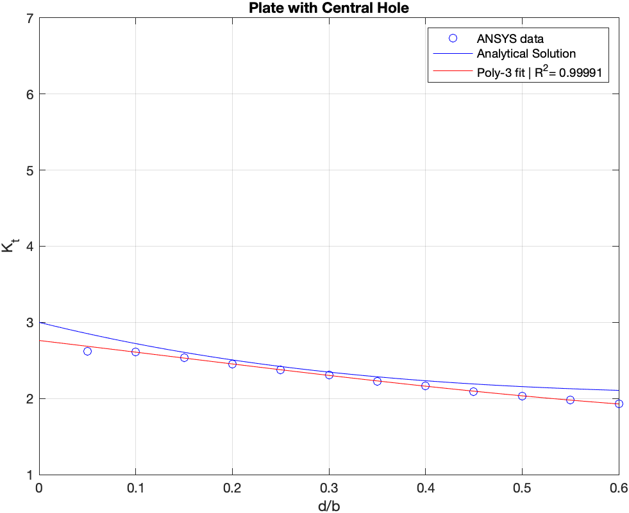

Figure 6. The stress concentration trend of a plate with central hole for different diameter to side length ratios.

The curve fitting was done with 3rd order polynomial on MATLAB and the achieved R2 value is greater than 0.999 which means the fit is accurate. An exponential curve of second order was also fit to this data, however, it performed relatively poorly; therefore, polynomial fit was selected. The y-intercept of the polynomial fit is around 2.76 and the curve converges towards 1.95 around the greatest diameter to side length ratio. The fit equation takes the form,

Where f(x) is the Kt fit, x= d/b ratio and the are fit coefficients which are:

{0.8921 -0.3377 -1.5083 2.7617}. T the analytical result that are derived from Kirsch Equations has the coefficients: {-1.527 3.667 -3.14 3.00} [2].

**Discussion/Comparison with Literature:**

In the book there are curve fits of stress concentration factors for commonly used engineering geometries. Stress concentration curves for pin-loaded and unloaded holes can be found in Figure 7.

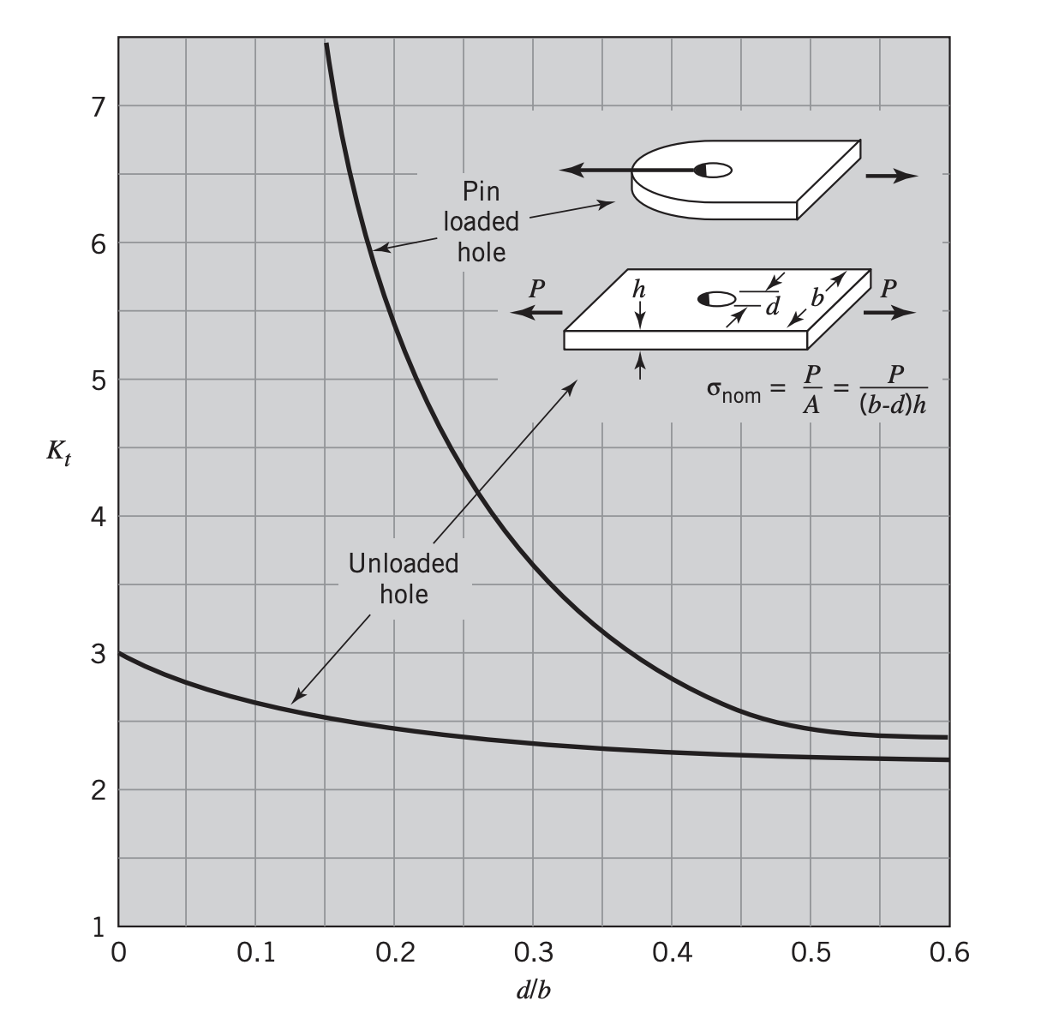

Figure 7. Stress concentration curve of a plate with pin-loaded and unloaded holes [1]

When we compare the stress concentration curves, there is slight variation between our fit and the curve given in the book. The y-intercept in Figure 2 corresponds to 3.0 and the curve converges to 2.2 while our fit was about 10% lower for all the diameter ratios. This is mainly due to ANSYS being a numerical tool instead of an analytical solution, therefore the offset is acceptable. There is fluctuation at small d/b ratios because the meshing cannot keep up with the shrinking hole diameter, therefore the meshing settings must be adjusted carefully. For instance, if the body meshing size gets smaller with the hole diameter the total computational load would increase drastically even for the places where the coarse meshing is enough. Preventing this lies in the meshing properties, one of the easy solutions is to introduce edge meshing or refinement towards the hole area which would improve the accuracy of the total solution and wouldn’t create as much computational load as body mesh adjustments since it only affects the vicinity of the hole. Overall, the trend that we came up with is quite strong in terms of R2 value and general shape, yet there is some offset with the literature. The study accuracy may be improved with slightly different geometries (long side of the triangle may not be enough to assume infinite) and finer mesh settings.

**List of References\***

[1] R. C. Juvinall and K. M. Marshek, *Fundamentals of Machine Component Design Global Edition, SI version*. Wiley, USA, 2020.

[2] Kirsch, E.G., "Die Theorie der Elastizität und die Bedürfnisse der Festigkeitslehre," Zeitschrift des Vereines deutscher Ingenieure, Vol. 42, , 1898.